ICT2202 Digital Forensics

Assignment 01

Developing a Solution for a Problem in Digital Forensics User Manual

Team J4

|  |  |
| --- | --- |
| **Name** | **Student ID** |
| Jasmin Yap Yi | 2001571 |
| Wee Jing Wei Shannen | 2002184 |
| Tey Shu Juan | 2002541 |
| Jerome Liew Han Rong | 2001546 |

**Step to download Audacity and Plug-Ins**

Step 1: Users need to download Audacity Application in their computer.

<https://www.audacityteam.org/>

Step 2: To use the plug-in dolphinattack Filter, download or clone the repository from Github

Figure 1 Download or clone the repository

Step 3: After download, unzip the folder. Copy the file dolphinattack.ny to the Plug-Ins folder of Audacity. E.g “Program Files\Audacity\Plug-Ins”

Figure 2 The file in Plug-Ins folder

Step 4: Open Audacity.

Figure 3 Audacity’s Application

Step 5: Click on Effect at the top



Figure 4 Audacity’s Toolbar

Step 6: Click on Add/Remove Plug-ins

Figure 5 Add plug-ins

Step 7: Look for the DolphinAttack Filter and click on Enable and then click on OK. The filter needs to be enabled before it can be used.

Figure 6 Popup window for Manage Plug-Ins

Step 8: Check that the Filter has been added in Effect. After enabling the filter, it should appear in the list.

Figure 7 Check that the filter has been added

**Steps to test the Plug-Ins**

Step 9: Open any audio file.

Step 10: Select the audio file and click Effect and then DolphinAttack Filter.

Figure 9 DolphinAttack Filter

Step 11: A popup box will appear asking the user what they want to do with the audio. If the user selects modulate with a carrier frequency of 40k Hz. The audio would be inaudible to human’s ear.

Figure 10 Modulate with a carrier frequency of 40k Hz

Before:

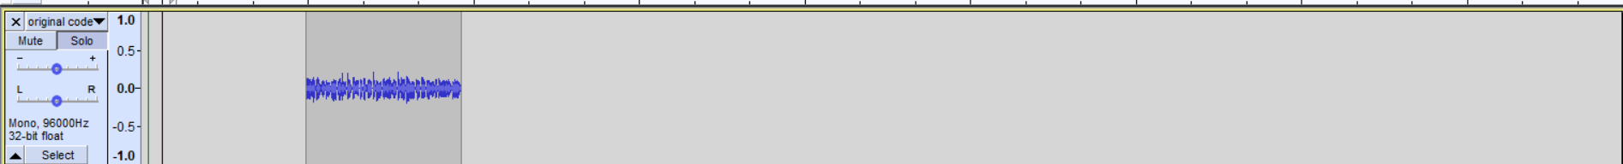

Figure 11 Waveform before Modulating the audio

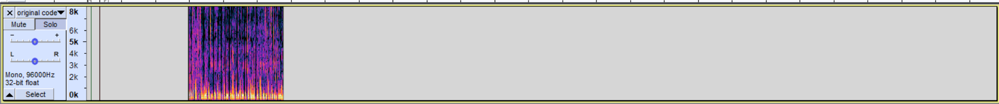

Figure 12 Spectrogram before Modulating the audio

After:

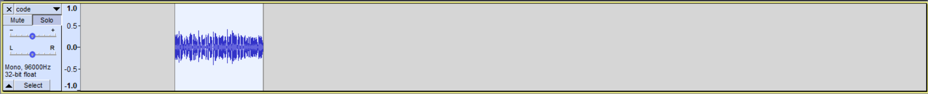

Figure 13 Waveform after Modulating the audio



Figure 14 Spectrogram after Modulating the audio

By modulating the frequencies in the audio, we are able to change the frequencies of it. It allows users to embed the modulated audio in another audio such as the screenshot above.

Step 13: If the users choose Demodulate with a carrier frequency of 40k Hz, the hidden message would be seen and heard.

Figure 15 Demodulate with a carrier frequency of 40k Hz

Before:



Figure 16 Waveform before Demodulating

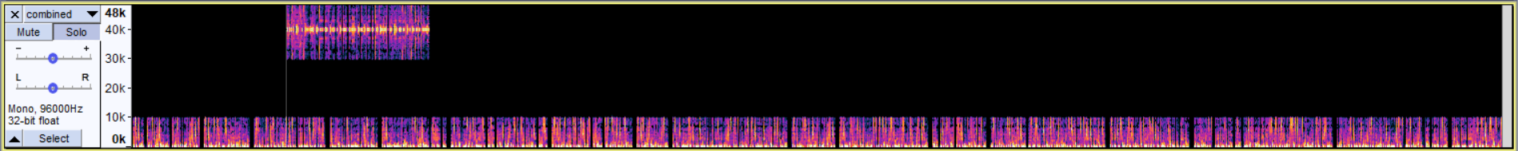

Figure 17 Spectrogram before Demodulating the audio

After



Figure 18 Waveform after Demodulating

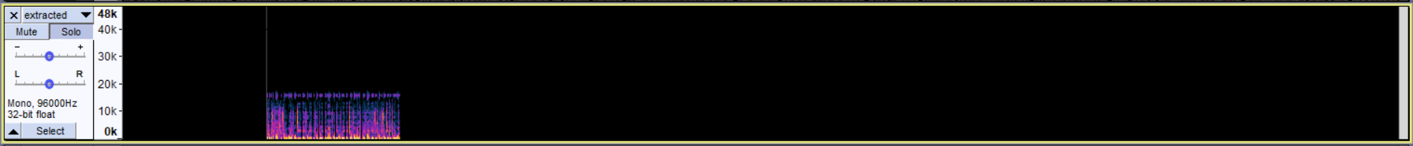

Figure 19 Spectrum after Demodulating

This is the secret message hidden in the audio file. Without demodulating the audio, we are unable to get the audio that is above 20k Hz. After demodulating, the carrier frequency is attenuated and brought to an audible frequency.

Step 14: If the user chooses to sanitize the audio. It will filter out frequencies above 20k Hz. When the user chooses to sanitize the audio, the carrier frequency does not matter.

Figure 20 Choosing sanitizing option

Before:



Figure 21 Waveform before sanitizing

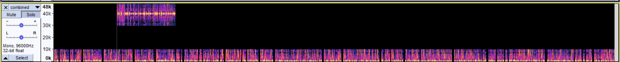

Figure 22 Spectrum before sanitizing

After:



Figure 23 Waveform after sanitizing

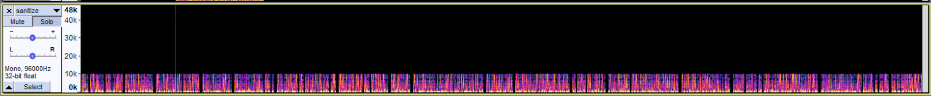

Figure 24 Spectrum after sanitizing

By sanitizing the audio, the frequencies that are above 20k Hz are gone. The audio that is left is in the audible range for humans.